EXPERIMENT 4

**Title:  To understand and apply the concept of Constraints.**

**Objective:** To understand the concept of data constraints that is enforced on data being stored in the table. Focus on Primary Key and the Foreign Key.

1.

Table : CLIENT_MASTER

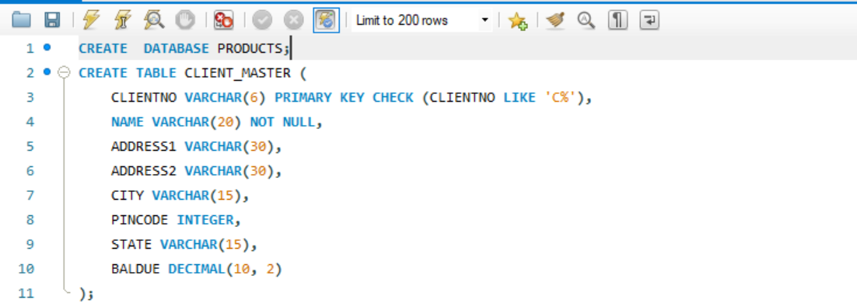

Table: PRODUCT_MASTER

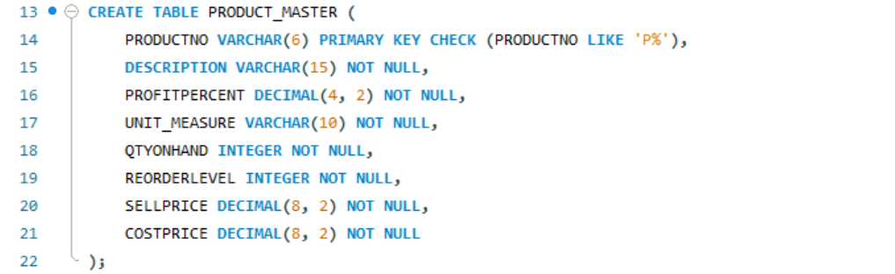

T

T

Table: SALESMAN_MASTER

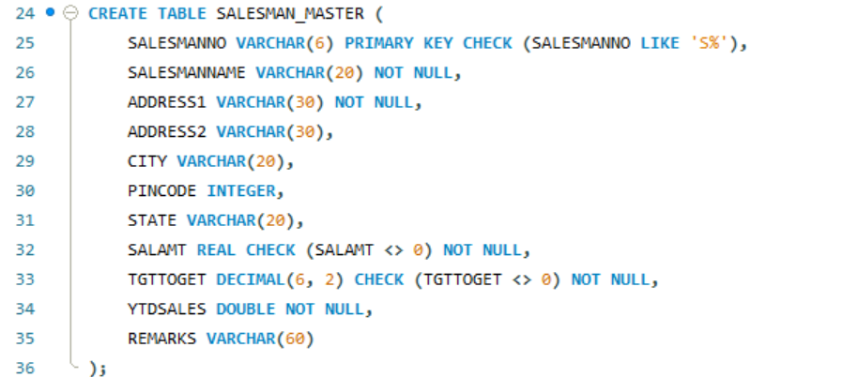

INSTERTING VALUES INTO CLIENT_MASTER

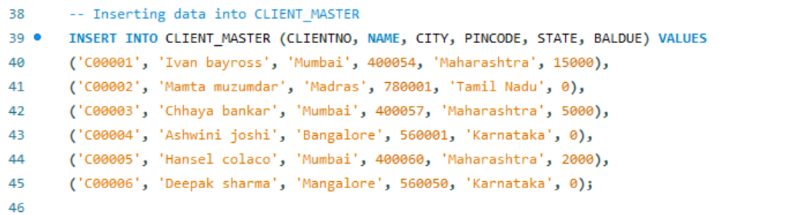

INSERTING INTO PRODUCT­_MASTER

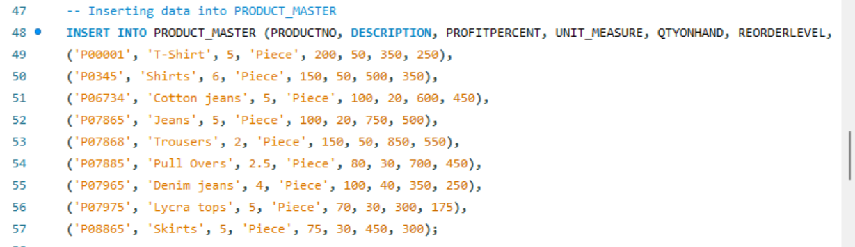

INSERTING INTO SALESMAN_MASTER

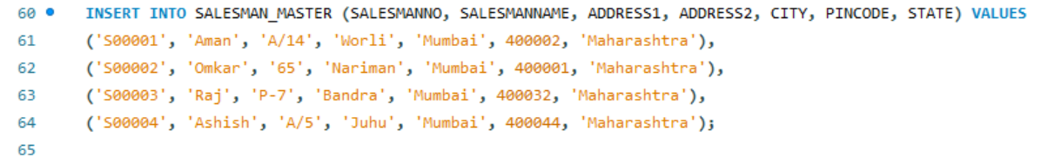

PERFORMING QUERIES

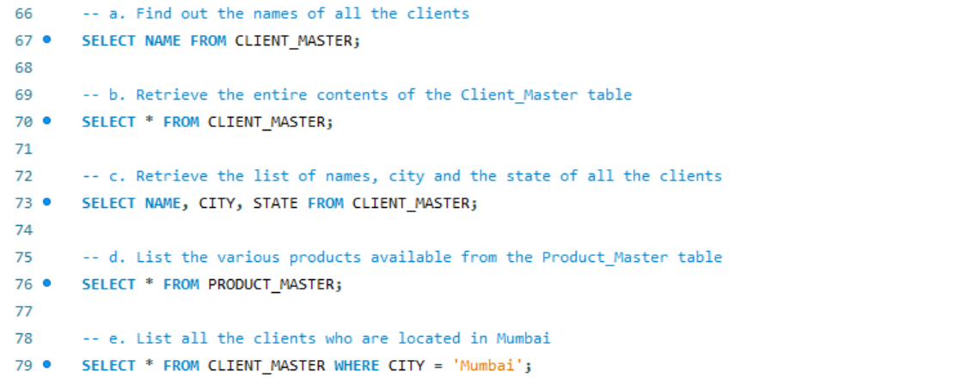

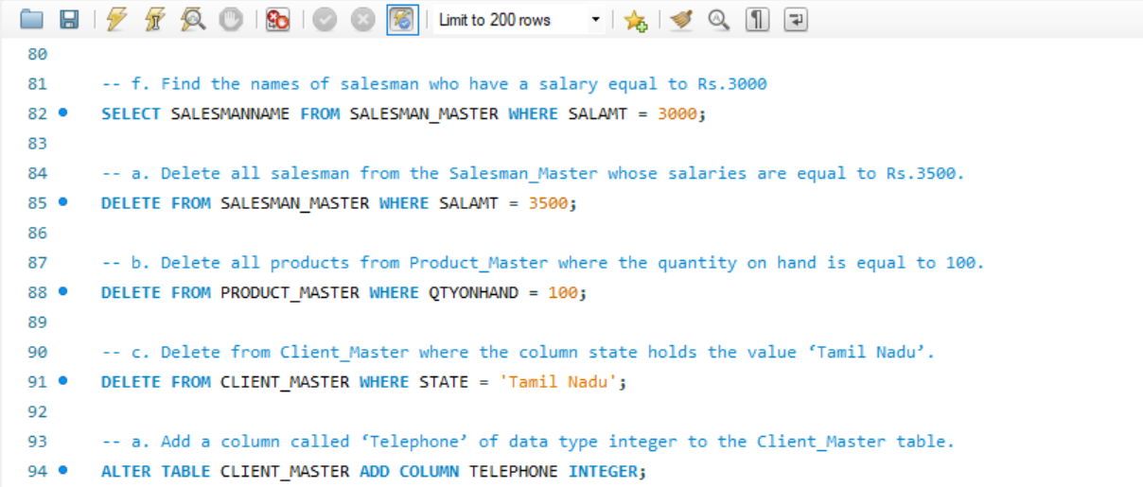

DESTROYING THE TABLE

